**Week-3**

**Exercise 1: Configuring a Basic Spring Application**

**1 . Create Maven project**

Group Id: com.library

Artifact Id: LibraryManagement

**2. Add Spring Dependencies in pom.xml**

<project xmlns="http://maven.apache.org/POM/4.0.0"

xmlns:xsi="http://www.w3.org/2001/XMLSchema-instance"

xsi:schemaLocation="http://maven.apache.org/POM/4.0.0

http://maven.apache.org/xsd/maven-4.0.0.xsd">

<modelVersion>4.0.0</modelVersion>

<groupId>com.library</groupId>

<artifactId>LibraryManagement</artifactId>

<version>1.0-SNAPSHOT</version>

<dependencies>

<!-- Spring Core -->

<dependency>

<groupId>org.springframework</groupId>

<artifactId>spring-context</artifactId>

<version>5.3.34</version>

</dependency>

</dependencies>

</project>

**3 .In src/main/Java**

1. **Create a package with name “com.library.repository”.Inside that package , add a file called BookRepository.java**

package com.library.repository;

public class BookRepository {

public void saveBook(String bookName) {

System.out.println("Saving book: " + bookName);

}

}

1. **Create a package with name “com.library.service”.Inside that package , add a file called BookService.java**

package com.library.service;

import com.library.repository.BookRepository;

public class BookService {

private BookRepository bookRepository;

public void setBookRepository(BookRepository bookRepository) {

this.bookRepository = bookRepository;

}

public void addBook(String bookName) {

System.out.println("Adding book: " + bookName);

bookRepository.saveBook(bookName);

}

}

**4. XML Configuration File**

Inside src/main/resources, craete a file called “aapplicationContext.xml”

<beans xmlns="http://www.springframework.org/schema/beans"

xmlns:xsi="http://www.w3.org/2001/XMLSchema-instance"

xsi:schemaLocation="

http://www.springframework.org/schema/beans

https://www.springframework.org/schema/beans/spring-beans.xsd">

<bean id="bookRepository" class="com.library.repository.BookRepository" />

<bean id="bookService" class="com.library.service.BookService" />

</beans>

**5 . MainApp.java**

import org.springframework.context.ApplicationContext;

import org.springframework.context.support.ClassPathXmlApplicationContext;

import com.library.service.BookService;

import com.library.repository.BookRepository;

public class MainApp {

public static void main(String[] args) {

ApplicationContext context = new ClassPathXmlApplicationContext("applicationContext.xml");

BookService bookService = (BookService) context.getBean("bookService");

BookRepository bookRepository = (BookRepository) context.getBean("bookRepository");

bookService.setBookRepository(bookRepository);

bookService.addBook("Atomic Habits");

((ClassPathXmlApplicationContext) context).close();

}

}

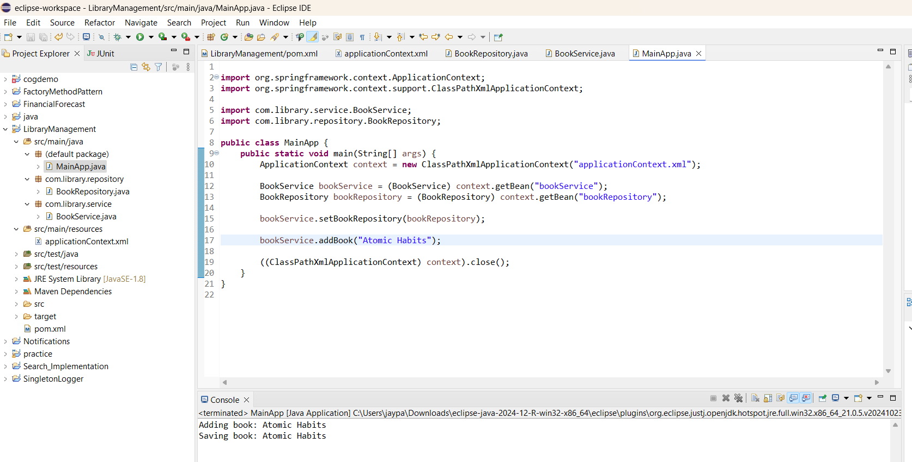

**Exercise 2: Implementing Dependency Injection**

**1 . Create Maven project**

Group Id: com.library

Artifact Id: LibraryManagement

**2. Add Spring Dependencies in pom.xml**

<project xmlns="http://maven.apache.org/POM/4.0.0"

xmlns:xsi="http://www.w3.org/2001/XMLSchema-instance"

xsi:schemaLocation="http://maven.apache.org/POM/4.0.0

http://maven.apache.org/xsd/maven-4.0.0.xsd">

<modelVersion>4.0.0</modelVersion>

<groupId>com.library</groupId>

<artifactId>LibraryManagement</artifactId>

<version>1.0-SNAPSHOT</version>

<dependencies>

<!-- Spring Core -->

<dependency>

<groupId>org.springframework</groupId>

<artifactId>spring-context</artifactId>

<version>5.3.34</version>

</dependency>

</dependencies>

</project>

**3 .In src/main/Java**

**i. Create a package with name “com.library.repository”.Inside that package , add a file called BookRepository.java**

package com.library.repository;

public class BookRepository {

public void saveBook(String bookName) {

System.out.println("Saving book: " + bookName);

}

}

**ii, Create a package with name “com.library.service”.Inside that package , add a file called BookService.java**

package com.library.service;

import com.library.repository.BookRepository;

public class BookService {

private BookRepository bookRepository;

public void setBookRepository(BookRepository bookRepository) {

this.bookRepository = bookRepository;

}

public void addBook(String bookName) {

System.out.println("Adding book: " + bookName);

bookRepository.saveBook(bookName);

}

}

**4. XML Configuration File**

Inside src/main/resources, craete a file called “aapplicationContext.xml”

<?xml version="1.0" encoding="UTF-8"?>

<beans xmlns="http://www.springframework.org/schema/beans"

xmlns:xsi="http://www.w3.org/2001/XMLSchema-instance"

xsi:schemaLocation="

http://www.springframework.org/schema/beans

https://www.springframework.org/schema/beans/spring-beans.xsd">

<bean id="bookRepository" class="com.library.repository.BookRepository" />

<bean id="bookService" class="com.library.service.BookService">

<property name="bookRepository" ref="bookRepository" />

</bean>

</beans>

**5 . MainApp.java**

import org.springframework.context.ApplicationContext;

import org.springframework.context.support.ClassPathXmlApplicationContext;

import com.library.service.BookService;

public class MainApp {

public static void main(String[] args) {

ApplicationContext context = new ClassPathXmlApplicationContext("applicationContext.xml");

BookService bookService = (BookService) context.getBean("bookService");

bookService.addBook("The Great Gatsby");

((ClassPathXmlApplicationContext) context).close();

}

}

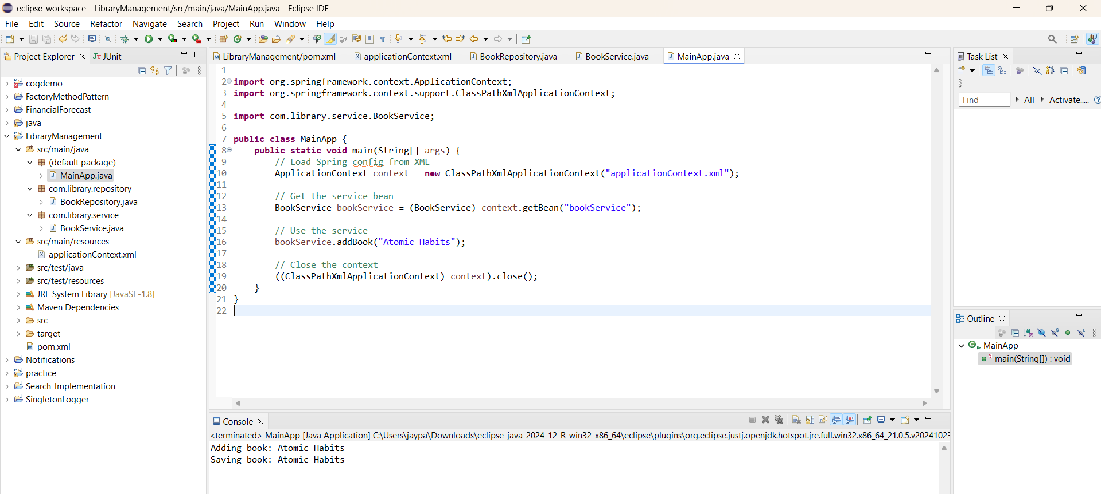

**Exercise 4: Creating and Configuring a Maven Project**

1. **Inside pom.xml file**

<dependency>

<groupId>org.springframework</groupId>

<artifactId>spring-context</artifactId>

</dependency>

<dependency>

<groupId>org.springframework</groupId>

<artifactId>spring-aop</artifactId>

</dependency>

<dependency>

<groupId>org.springframework</groupId>

<artifactId>spring-webmvc</artifactId>

</dependency>

<build>

<plugins>

<plugin>

<artifactId>maven-compiler-plugin</artifactId>

<configuration>

<source>1.8</source>

<target>1.8</target>

</configuration>

</plugin>

</plugins>

</build>

1. **Create a dummy class to test**

public class Test {

public static void main(String[] args) {

System.out.println(" Project is working!");

}

}

